Voice Controlled LED
Description:
A toy that responds to claps or loud sounds using a sound sensor module and Arduino.
Block Diagram:
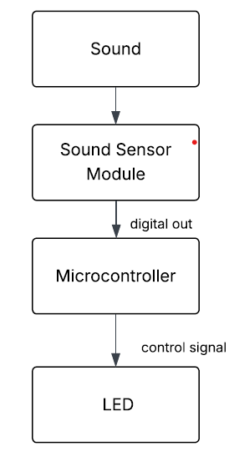
Pinout / Circuit Connection:
Sound Sensor Module → Arduino D2
LED → Arduino D8/D9
Components Required:
Arduino UNO
Sound Sensor Module
LED
Resistors
Breadboard
Jumper wires
Working Principle:
When sound sensor detects a loud clap, Arduino triggers a toy action such as moving a motor, lighting an LED, or buzzing.
Operation (Step-by-Step):
Connect sound sensor to Arduino.
Upload sound-detection code.
On clap, toy activates motor/LED/buzzer.
Code:
const int soundSensorPin = 7; // Digital output pin of sound sensor
const int ledPin = 13; // LED pin

void setup() {
pinMode(soundSensorPin, INPUT);
pinMode(ledPin, OUTPUT);
Serial.begin(9600);
}

void loop() {
int soundState = digitalRead(soundSensorPin);

if (soundState == HIGH) { // Sound detected
digitalWrite(ledPin, HIGH);
Serial.println("Sound detected! LED ON");
} else {
digitalWrite(ledPin, LOW);
Serial.println("No sound. LED OFF");
}

delay(100); // Small delay for stability
}

Conclusion: (Predefined/self-written)
The Voice Controlled Toy introduces sound sensors in interactive electronics.
For Your References:
[1] Arduino Project Hub, 'Sound Sensor Tutorial'

